# Blinking Exercises

Blinking Sequence:

CLOSE-PAUSE-PAUSE-OPEN-RELAX

CLOSE-PAUSE-PAUSE-SQUEEZE-OPEN-RELAX

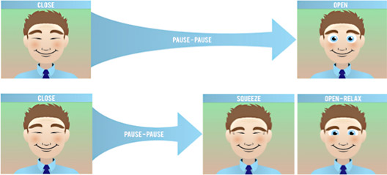

**Frequency:**

* To be completed every 20 minutes, 20 X a day to improve muscle memory.
* Use an audible signal (egg time, phone or computer alarm) to remind you**.**
* IPHONE App: **Korbblinkingexercise**

**Exercise instructions:**

1. Close both eyes normally, pause 2 seconds, and open. Note: To check your blink, place your finger gently on the bone to the outside corner of one eye. When you are blinking “normally”, you should feel very little movement from the muscles around your eye.
2. Close the eyes normally again, pause 2 seconds and then aggressively squeeze the lids together (as if you are trying to crack a walnut with your lids) for 2 seconds. Open both eyes.
3. Repeat every 20 minutes, 20 X a day.

**Awareness:**

Your blink rate naturally decreases with sustained visual activity. For example, if you spend a lot of time on the computer or other digital media, doing close up work, you probably have a decreased blink rate and might want to post a copy of the blinking exercises nearby as a reminder.

**Helpful Hint:**

If you are having difficulty incorporating the blinking exercises into your schedule, choose an activity you do routinely such as answering phones or looking at email or text messages. Doing the blink exercises every time you perform this activity will help to make complete blinking, a habit.